Made By

Sarah Nowlan  
Sridhar Ponnusamy  
Aleksandr Semenov  
Kamakshi Mansukhani  
Param Jaswal

**IDENTIFY EM!** 

Math Final SUbmission

# **Table of Contents**

# Our Problem

# Our Dataset

# Data Pre-processing

# Libraries and Modelling

# Evaluation Metrics

# Results

# Conclusion

**A picture is worth a thousand words**

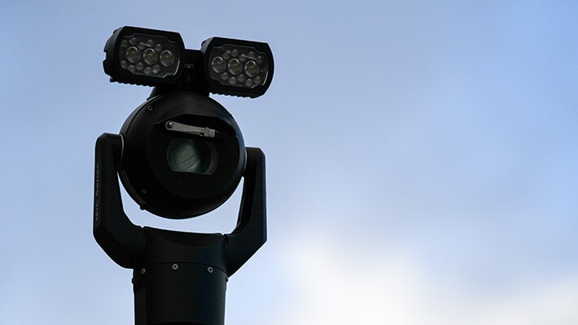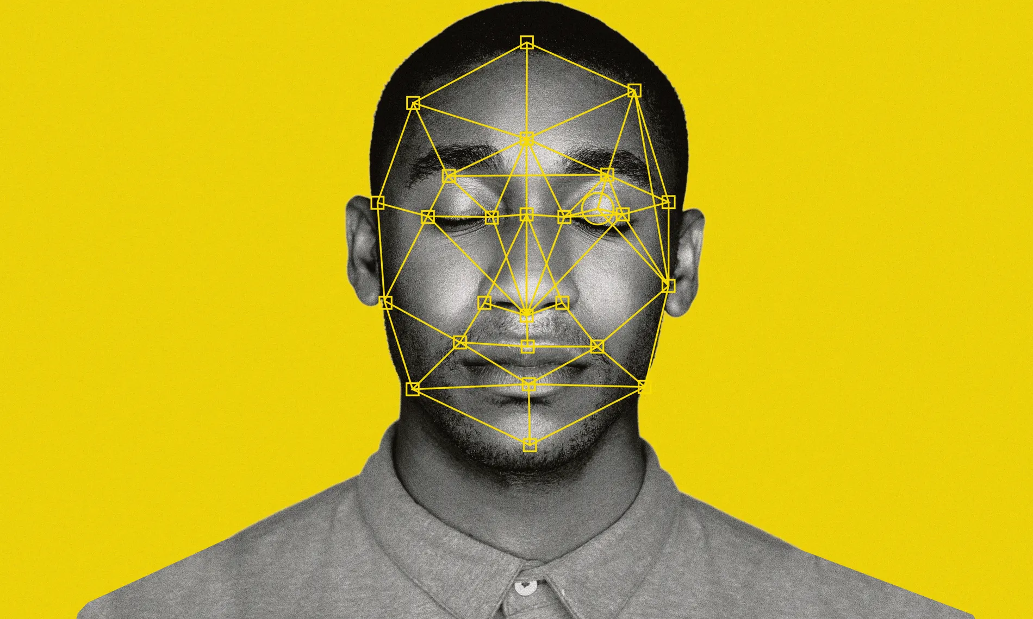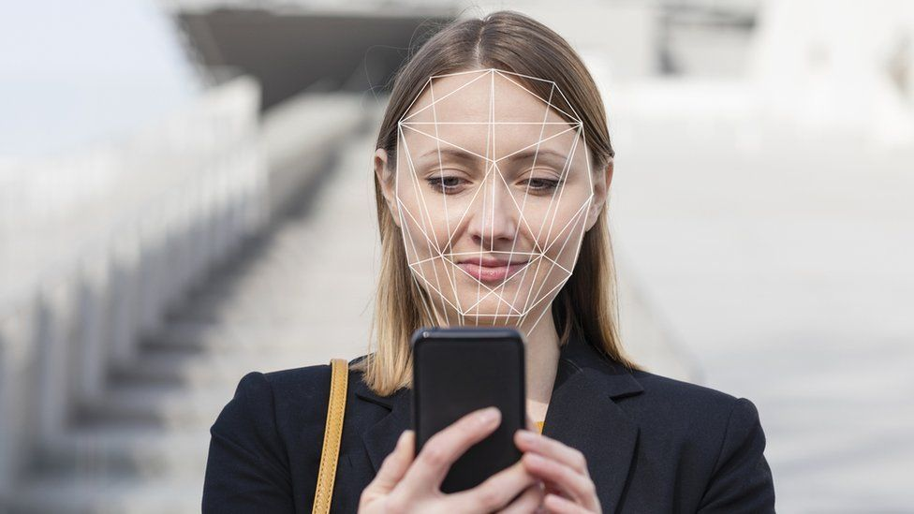

**The Problem Statement**

When we started working on the project, we thought that there might be many ways to improve people’s lives on how to avoid big queues, which is especially important during the pandemic. So, we’ve considered our problem as classifying people’s faces. We decided to train the system with the use of leaders of the political parties during the 2021 Canadian federal election.

**The main target**

* Our problem was classifying the faces of the leaders of the political parties during the 2021 Canadian federal election.

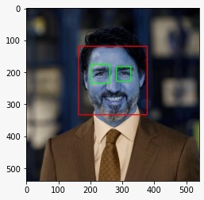

**The Dataset**

Our dataset contains 497 photos, which were scrapped from the web, with an equal distribution between the 5 classes. Below is an example from each of the 5 classes.

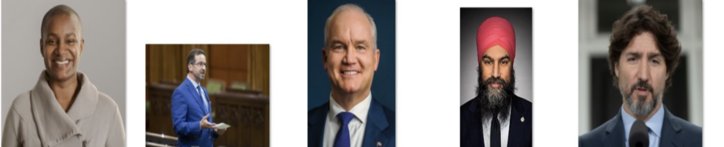

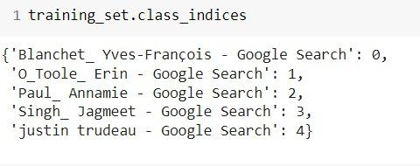

**Preprocessing the Data**

* The possible classes for the classification model are:
* Annamie Paul,
* Jagmeet Singh,
* Justin Trudeau,
* Erin O’Tool,
* and Yves-François Blanchet.
* The data is split into training and testing datasets containing 431 images and 66 images respectfully.
* This is supervised learning with the classes being labelled by the indexes in the following image.
* When we look at any image, most of the time we identify a person using a face. An image might contain multiple faces, or  the face can be obstructed and not clear.
* The first step in our pre-processing pipeline is to detect faces from an image using the cascade classifier. Once the face is detected, we will locate the eyes, if two eyes are detected then only, we keep that image otherwise discard it.
* In the images below you may see an example of how our eye recognition works.

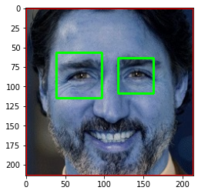

* Detect the face in the photo
* Locate the eyes, check that they are in eye constraint
* Cascade classifier to detect the eyes and front faces
* Photos are removed if both eye can not be located

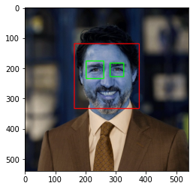

Here you may notice some photos which were removed from our dataset due to the inability to detect both eyes during the pre-processing.



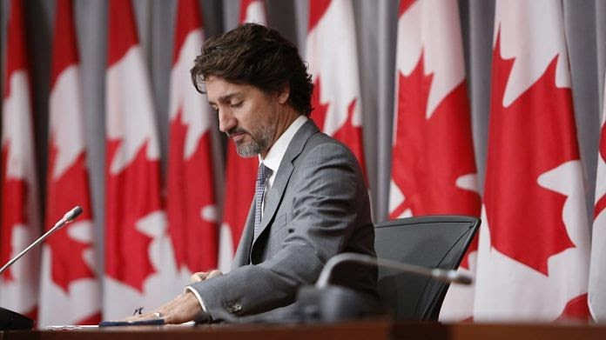

* Our next task was to crop the photos containing just the face of the person we are trying to classify. This makes it easier for the model to detect the person by removing not important objects from the image that could potentially distract our model.
* The dataset will now be populated with only the faces of our target people.
* Next we cropped the photos to just contain the faces
  + removing irrelevant objects
* Resized to fit Inception V3 photo constraints

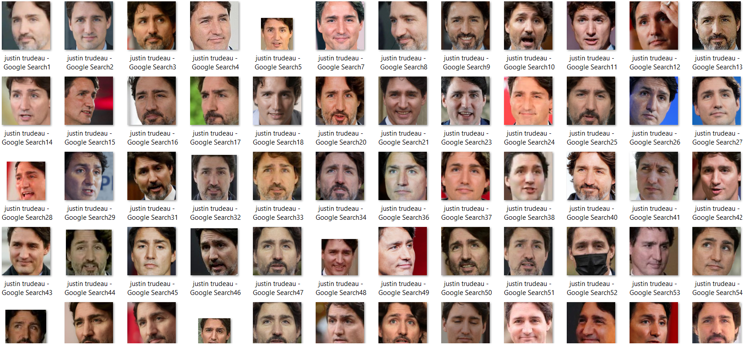

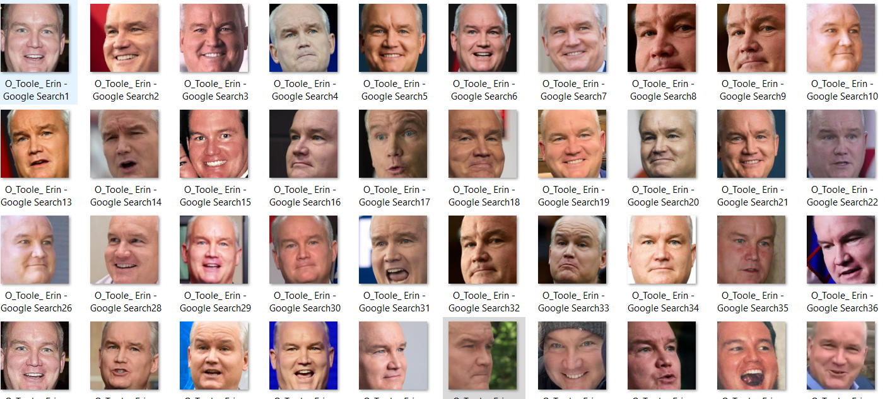

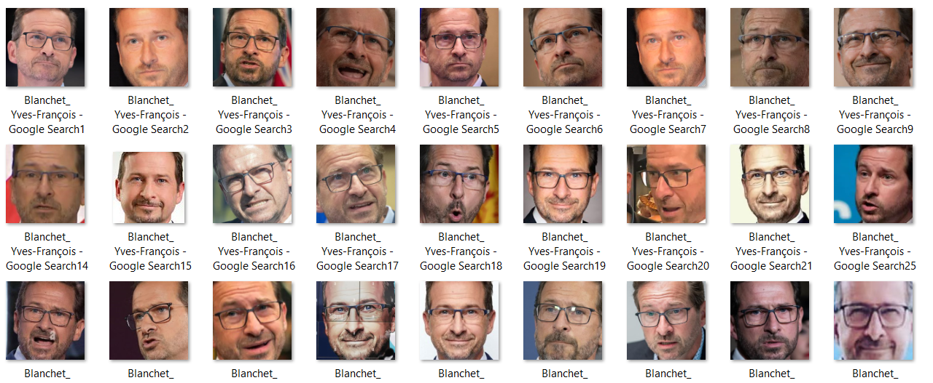

**Our Model**

Libraries, Modelling

* Inception V3 using keras which highly includes transfer learning.
* Inception V3 is a widely-used image recognition model that has been shown to attain greater than 78% accuracy on the ImageNet dataset. Based on the paper “Rethinking the inception Architecture for Computer Vision” by Szegedy.

***More information on inception V3 can be found on :***

***<https://cloud.google.com/tpu/docs/inception-v3-advanced>***

More About Inception V3

* ImageNet dataset for weighs:
  + Over 10 million URLs of labelled images
  + Million of which have bounding boxes for precise location of labelled objects.
* Inception requires images to be 299X299X3 pixels

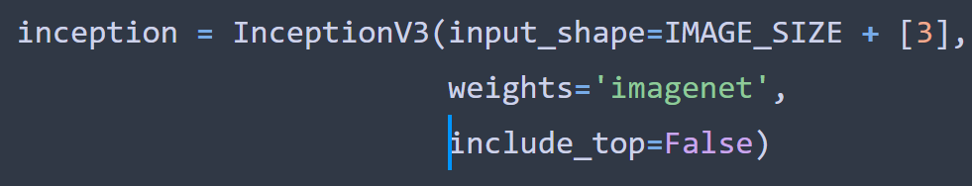

* While having a relatively small dataset, a super-effective technique is to use Transfer Learning where we use a pre-trained model. This model has been trained on an extremely large dataset, and we would be able to transfer weights which were learned through hundreds of hours of training on multiple high-powered GPUs.
* We are using the Inception-v3 model in the project, which is a widely-used image recognition model that has been shown to attain greater than 78% accuracy on the ImageNet dataset.
* Transfer Learning has become immensely popular because it considerably reduces training time, and requires a lot less data to train on to increase performance.

The model training techniques

* Small Dataset means transfer learning with pre-trained model will be effective
* Implemented early stopping to avoid overfitting

When we went to train our model, we wanted to ensure we avoided our model overfitting, so we implemented early stopping to end the training early if the validation loss suddenly started to increase.



**The Running of the Algorithm**

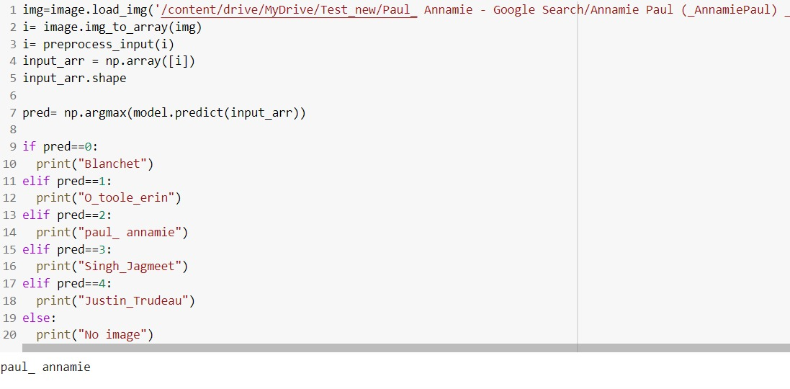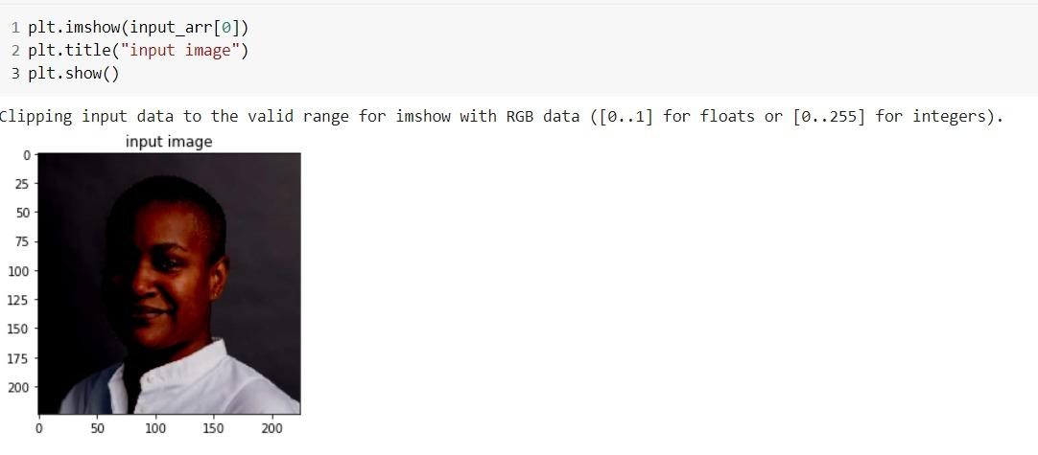

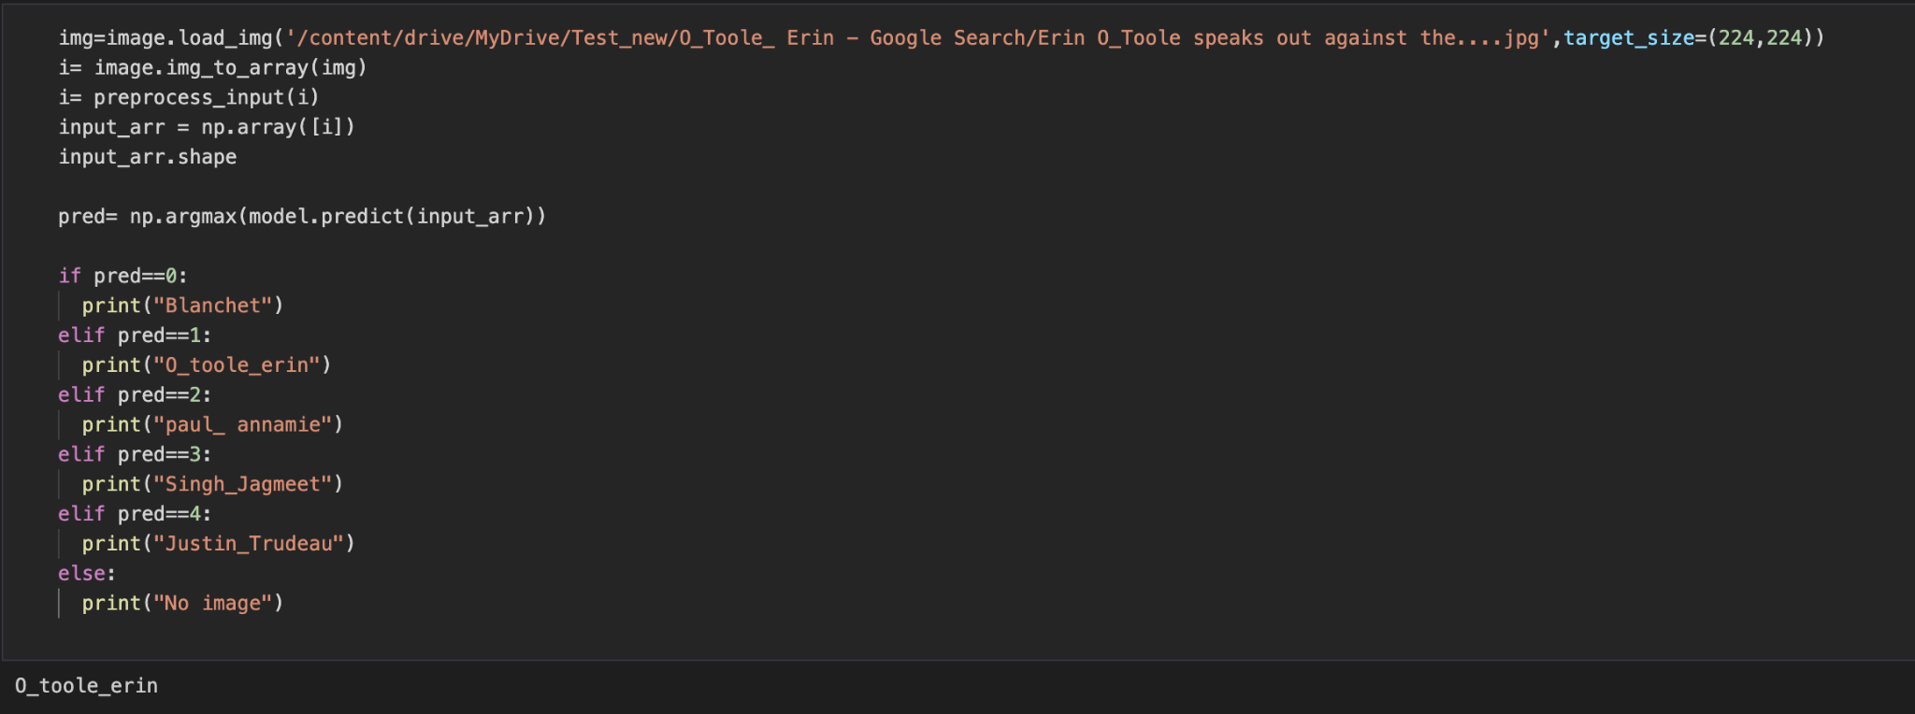

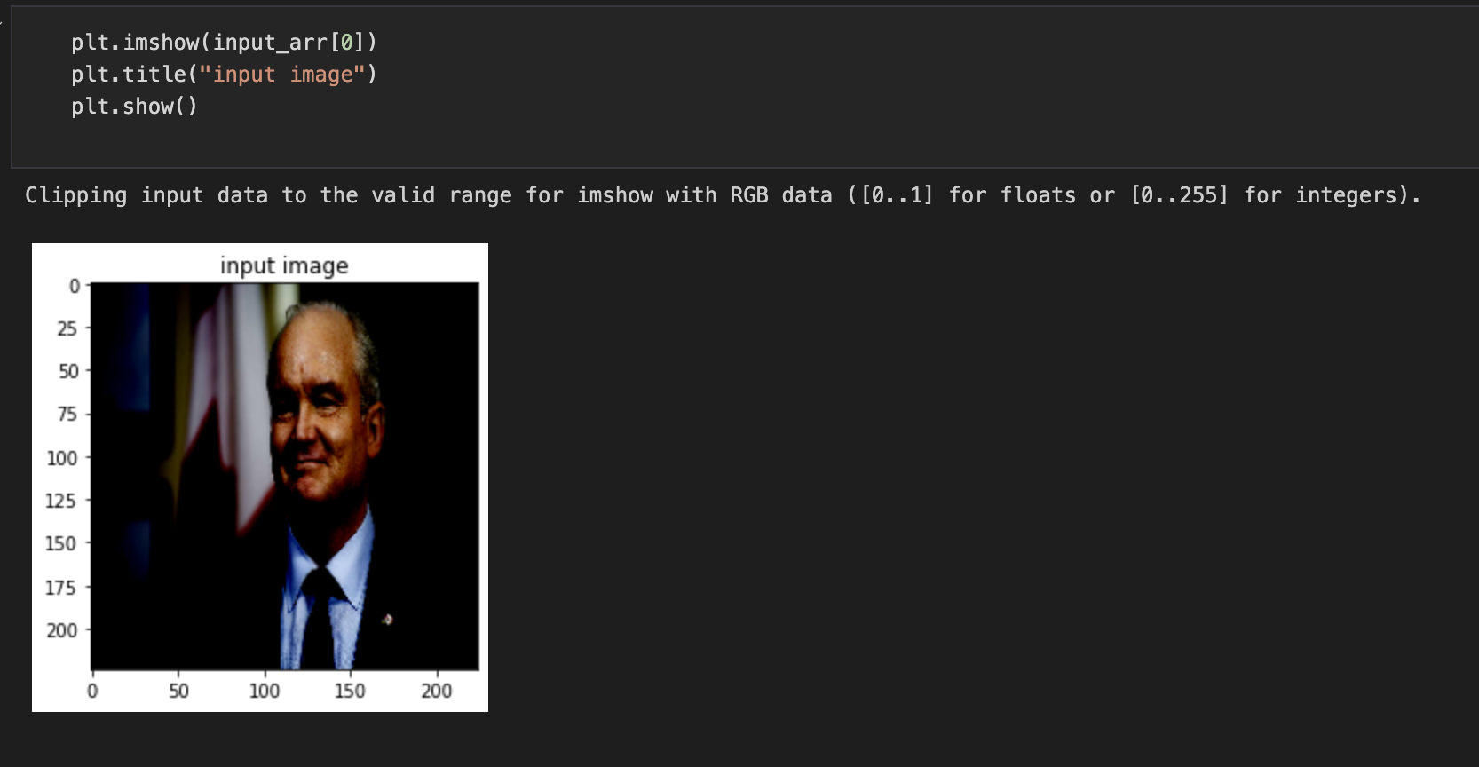

**Model Summary**

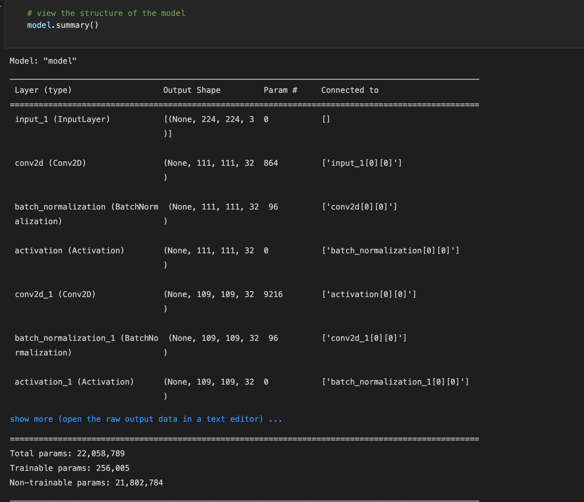

**Results**

The dataset used to train our model was really well balanced so we decided that we would be using accuracy for the evaluation metrics.   
When running our accuracy test on our model using the test dataset, we got a score of 96%, which we find good, yet still improvable.   
The performance of our model on training and validation datasets can be visualized with the help of accuracy and loss graphs as follows:

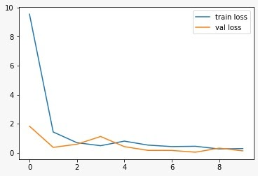

**We were able to achieve an accuracy score of 96%**

* With 5 target classes we decided to use
* categorical_crossentropy as the loss metric

**We get the same accuracy if we increase the epoch.**

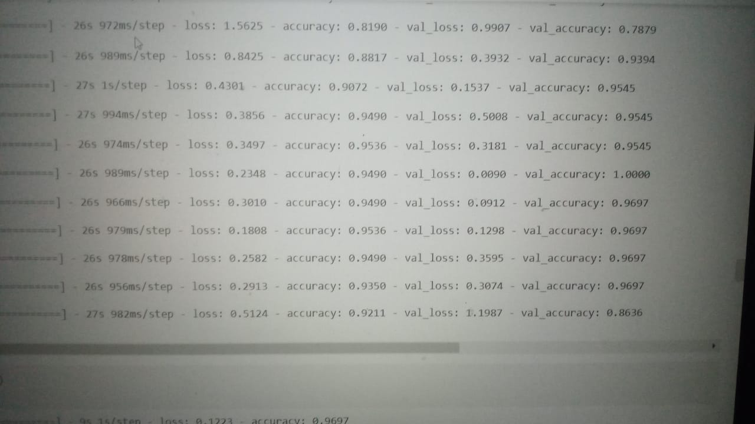

**Training Accuracy**

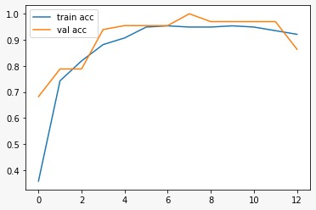

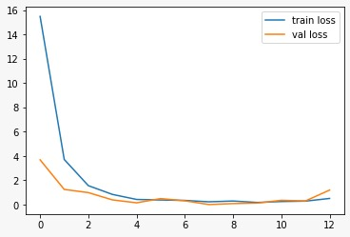

* Maximum epochs are 15
* if we increase the epoch , it will give the overfitting.
* Maximum iteration is 16.

**In short**

* If we go beyond 16 epoch, model will overfit.
* It will stop the iteration

**Conclusion**

**Finn**

**Jake**

**Kate**

**Stacy**

**Chris**

**Alex**

* After about 20 minutes, we were able to achieve an accuracy of 96%. A call-back can very easily be implemented after we reach a certain accuracy.
* Therefore, the above results substantiate that the model has successfully classified almost all the images. Therefore, it can undoubtedly be inferred that the model predicts all five classes quite well although not perfectly.
* The model can further be trained for more epochs for further better performance.